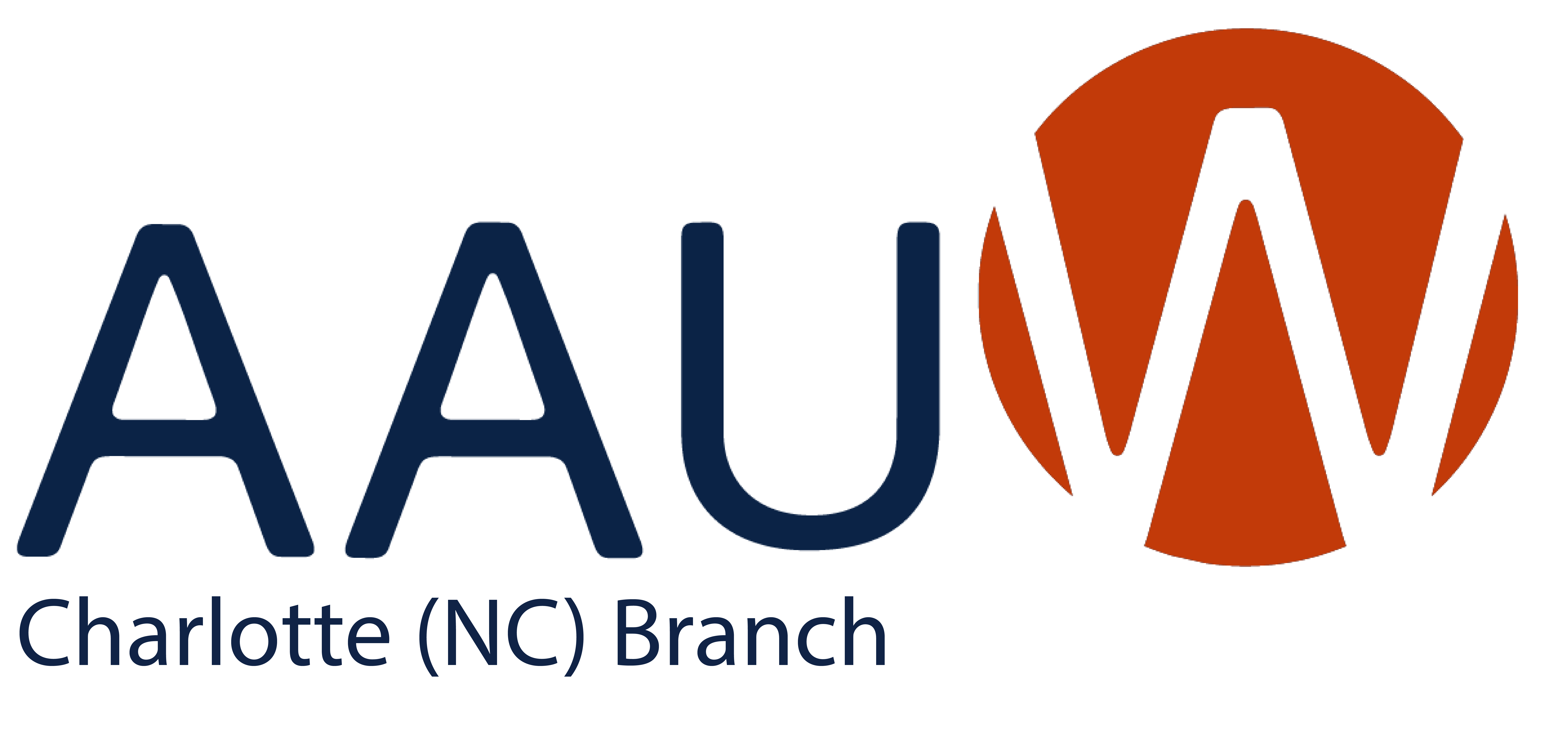
website: https://charlotte-nc.aauw.net/ Address: PO Box 26545, Charlotte, NC 28221
“Alone we can do so little; together we can do so much.” Helen Keller
Mission Statement: Our mission is to advance equity for women and girls through advocacy,
education, and research. AAUW empowers all women and girls to reach their highest potential.
November Event –Help Us Help Others

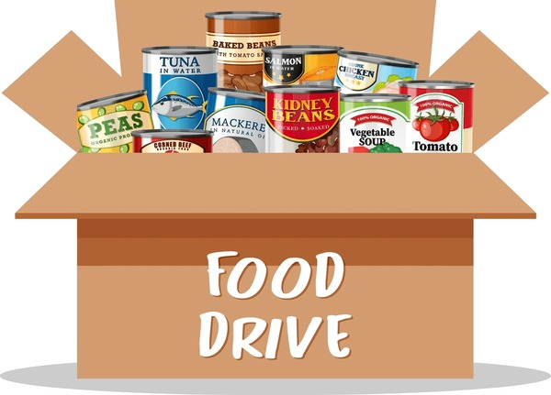 | Date: Saturday, 11-15-25  Time: Noon  Location: Cotswold Pizza Peel,  4422 Colwick Road, Charlotte  Description: Food Drive for the needy and a chance to share a meal with other local AAUW members.

Please plan to join your AAUW colleagues at our Thanksgiving Dutch treat luncheon and canned food drive. This is an opportunity to visit with fellow AAUW members AND help those in our community who are struggling to put food on the table during this holiday season.

Please bring canned goods to donate to a local food pantry. Discussion topics will include vacancies on the Board and the AAUW December event.

December Event –- Park Road Book Drive

Date: Saturday, December 13, 2025
Time: Noon
Location: Park Road Books, 4139 Park Road, Charlotte, NC
Description: Support education by purchasing requested books for students. The books and/or donations support Title 1 schools in our community.

Please Welcome Our New Members

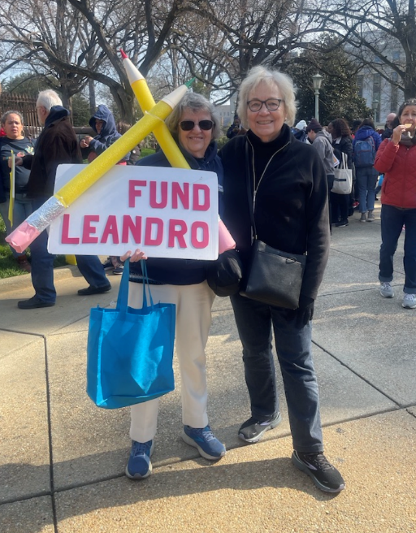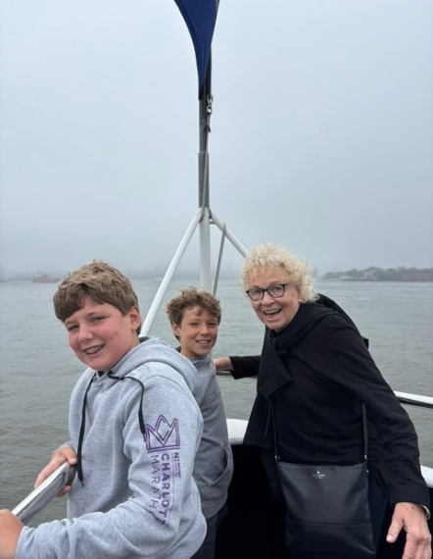 | Laura Cooper has worked as a teacher, school administrator, and district leader in urban and suburban districts in Arizona, Massachusetts, and Illinois. She helped create the Minority Student Achievement Network (MSAN), a network of 27 multiracial districts working together and with researchers to eliminate achievement gaps that persist in schools. She served on the Leadership Team of the Strategic Education Research Partnership that created the model for bringing together researchers and practitioners to address the real problems of practice. More recently, Laura has served as a consultant to public, charter, and turnaround schools, teaching teachers and schools leaders in public and charter schools how to transform schools by providing a coherent focus on improving teaching and learning. Laura has presented at numerous national education conferences and has written for The Harvard Ed Letter, ASCD Express, Journal of Education for Students Placed At-Risk, and Theory into Practice. Her work focuses on addressing inequities in student achievement by strengthening teachers’ and administrators’ capacity to ensure that all students are successful in school and by bringing together the wisdom of practice and the knowledge from research.
Shannon Lalor received a doctorate in History from the University of Florida and taught colonial and modern Latin American history at High Point University. She began her career as a museum professional, working in an array of museums and science centers across the United States. She managed two multi-million-dollar National Science Foundation-funded projects that sought to improve the teaching of science and mathematics in elementary and middle school classrooms through teacher professional development and teacher-scientist partnerships, respectively. Her current research interests include women and gender, slavery in the early modern Iberian Atlantic, and the early colonization of the Caribbean. She has presented her research at conferences in the US, Italy, and Ireland. Shannon is currently working on a manuscript that explores women’s power in the nascent colonial Spanish Empire of the fifteenth and sixteenth centuries.
Take the Pledge for Equity

AAUW’s strength is our collective voice. We’re asking everyone in our community to take the pledge for gender equity.
I pledge to:
- Speak up in my community when I see attacks on equity.
- Engage in events, like town halls, school board meetings, or public demonstrations.
- Contact my elected officials when legislation threatens access and equity in education.
- Support AAUW and other organizations working to protect our rights.
- Seek the facts — beyond the headlines — of how policy impacts women and girls and share with five people I know.
I pledge to be part of a continuing movement in shared purpose and community.

Your pledge to support protection of women's rights can be extended by participating in AAUW's national advocacy for the top priority focus of equity in higher education. Leaders will choose advocacy activities based on critical need, political viability, and potential for distinctive AAUW contribution or leadership. When you receive proposals for action from AAUW, please act on them.
Both AAUW and AAUWNC offer numerous opportunities to learn about women's issues and what you can help advocate for. You should receive information about upcoming programs that will be on zoom and usually can access them later if you cannot watch the live stream.
https://www.aauwnc.org/events/
https://www.aauw.org/resources/programs/webinars/

Looking Forward…
Your Board of Directors is working to strengthen the AAUW Charlotte Branch. We want to engage our members in activities that continue to support the AAUW mission and promote camaraderie through worthwhile and fun activities.
Below are some ideas being considered. Please share your thoughts on these ideas and provide input on others you may have. Thank you.

December | Park Road Books (see above).
January | - Partner with the Salisbury branch for brunch at a wine-tasting room.  - Mini-tech month—sign up for online courses of interest. For example, Intro to AI, Social Media Essentials, Google Account & Free Software Tools, etc.
February | Partner with Johnson C. Smith University to celebrate Black History Month.
March | Engage a guest speaker to celebrate Women’s History Month and talk about opportunities for women in the workforce.
April | Recognize Financial Literacy Month. Program yet TBD.
May | Mother/Daughter Tea.
June | End of year Luncheon.

President  AAUW Charlotte Area Branch 2025-2026 Board Members | Dr. Pamela Oviedo
Membership Vice President
Finance Officer
Public Policy Chair | Lucille Howard
STEM Chair
Recording Secretary and Newsletter Editor | Janet McClay
Past Co-Presidents | Rita Law and Marleen Hansen

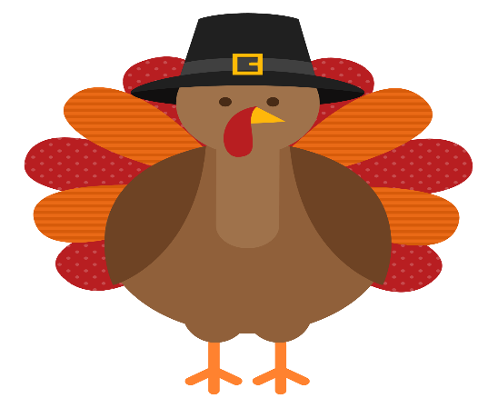  This Photo by Unknown Author is licensed under CC BY-NC | Wishing all a safe and  Happy Thanksgiving!

Prepared by Janet McClay
Janet.mcclay24@gmail.com

