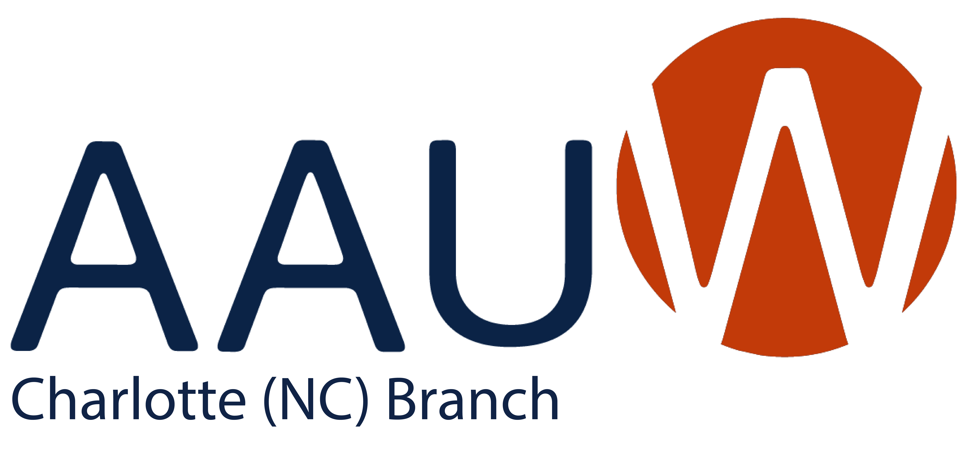
website: https://charlotte-nc.aauw.net/ Address: PO Box 26545, Charlotte, NC 28221
“Alone we can do so little; together we can do so much.” Helen Keller
Mission Statement: Our mission is to advance equity for women and girls through advocacy,
education, and research. AAUW empowers all women and girls to reach their highest potential.
A Letter from Our President

Dear AAUW Charlotte Members,
First and foremost, this is my first time sharing information in the newsletter as your President of the AAUW Charlotte Branch. I must say—with God, all things are possible. I never imagined I would be in this role, leading such wonderful women. Thank you for believing in me and supporting me.
Happy Fall! As the leaves begin to turn and a refreshing breeze fills the air, I hope you’re taking time to enjoy the beauty of the season. Autumn is a wonderful time for reflection—to look back on the progress, challenges, and accomplishments we’ve all experienced over the past ten months.
I want to extend my heartfelt thanks to everyone who attended our recent Chat & Chew on September 4, 2025, at Portofino’s. It was a pleasure seeing new and long-term members connect over great food and engaging conversation. The League of Women Voters (LWV) spoke briefly and shared information regarding NC Community Resolves for Fully Funded Public Schools.
Our Chat & Chew events, held quarterly, are a special opportunity to strengthen our community and welcome new faces. I encourage everyone to attend when you can. Future event locations will be chosen with input from branch members — your suggestions are always welcome!
Our October virtual event, held on October 11th, celebrated Hispanic Heritage Month by showcasing LAWA (Latin Americans Working for Achievement), a nonprofit organization advancing the education and quality of life of Latinos in the Charlotte region through scholarships, academic, and cultural programs. CEO Daniela Izurieta, a former LAWA scholarship recipient, shared how the organization’s support helped her pursue higher education. Other LAWA alumni also shared how receiving scholarships impacted their lives and careers.
Looking ahead, our goal before the November elections in Mecklenburg County is to host a conversation with local officials running for office. A date for this event will be shared soon.
Finally, sending belated birthday wishes to our September birthdays and early happy birthday wishes to all those celebrating in October. We also extend our deepest condolences to those who have recently lost loved ones, especially to our branch, as we mourn the passing of our Treasurer, Sally Bailey. May she rest in peace.
Let’s continue to be kind, stay positive, and cherish each day, because tomorrow is not promised.
Thank you for your continued support and commitment to our mission. Let’s keep building connections, empowering women, and growing stronger together.
Warm regards,
Pamela Oviedo, Ed.D.
President
AAUW Charlotte Branch

The Public School Funding Crisis

The Mecklenburg Resolves urging the NC General Assembly to fund public education at a level that provides a quality education for every student were presented to North Carolina legislators (primarily senators) or their staff members last month. New AAUW member Laura Cooper was a member of the delegation who contacted legislators on the day they returned to Raleigh after a month's break. Those House members not in their offices will have found them when they opened their doors the next day.
The Resolves, which many of you signed, had almost 2,000 signatures by citizens from at least 61 counties across the state.
Even though the first set of signatures has gone to legislators, more are being solicited, especially from areas outside the big metropolitan areas so legislators will see that residents across the state are concerned about the lack of adequate funding for education.
If AAUW members have friends or relatives in western North Carolina, in the southern Piedmont areas, Rockingham County (home of Sen. Phil Berger) or the northeast corner of the state and anywhere else, please send a copy of the resolves to them so they can also sign by using the QR code on the resolves that were sent to each of you.
Lucille Howard, Public Policy Director
Below are the Resolves and a QR code to sign.

North Carolina Community Resolves for Fully Funded Public Education
Whereas the North Carolina General Assembly is legally required by our state constitution to fund a sound, basic public education for every child.
Whereas North Carolina public schools educate 84% of K-12 students, serving 1.5M students annually and welcomes all children regardless of ability, special needs, zip code, income or family background.
Whereas successful public education provides productive citizens who are caring and contributing members of our democracy.
Whereas public schools serve as community centers and drive local economies. In 82 of 100 North Carolina counties, public schools are one of the top 3 employers.
Whereas NC public schools are struggling to fully staff classrooms and meet basic needs due to chronic underfunding and rising costs;
- Teachers are the #1 school-related factor that impacts student outcomes, yet North Carolina ranks 43rd in the nation for average teachers’ pay —$13,738 below the national average and five spots lower than last year—and is losing teachers to neighboring states due to uncompetitive salaries.
- North Carolina ranks 48th in the nation for per-pupil spending, $5000 less per student than the national average.
Whereas our state’s long-term economic competitiveness and #1 business ranking depend on a strong K-12 public education system that prepares students to be effective members of the growing North Carolina workforce.
Whereas billions in public funds have been allocated to private school vouchers and divert funding for public education. In rural counties, the vast majority of students attend public schools and there are few if any private school options.
Whereas state tax cuts for individuals and corporations have shifted more responsibility of funding education to local governments, which disproportionately hurts rural counties with smaller populations and lower tax bases.
- Boards of County Commissioners are asked to close the public education funding gap despite critical demands for other vital community services.
We, the residents of North Carolina, strongly urge the North Carolina General Assembly to stop the chronic underfunding of our public schools.
Public education is the foundation of a strong, inclusive, and thriving North Carolina. Defunding schools defunds our children’s futures.
Our children deserve better. Our educators deserve better. North Carolina deserves better. Legislators: Do the right thing and fully fund public education.
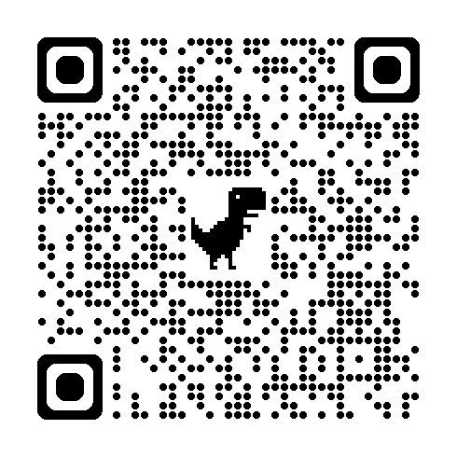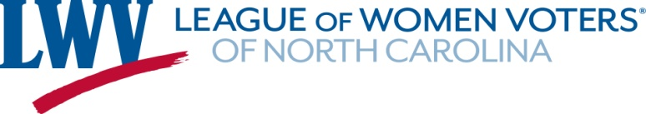
Read and sign the Resolves by using this link or the QR code.
Copies will be presented to the NC Legislators, demanding that they do the right thing for NC children and fully fund public education.

October Webinars and Events
AAUW Money Smart: Smart Finances
Thursday, October 23, 2025 | 3:00 - 4:00 pm ET
Branches in Action: A Century of Advocacy, Fundraising & Impact
Thursday, October 23, 2025 | 4:00 - 5:00 pm ET
Defending Equity in Education: DEI Rollbacks & Curriculum Bans
Tuesday, October 28, 2025 | 2:30 - 3:30 pm ET
---------------------------------------------------------------------------------------------------------------
MEMBERSHIP COUPON
The Shape the Future Campaign discount of 50% off national dues for new members (those entirely new to AAUW or rejoining after two or more years)! Use the coupon code STFFY26 at checkout. The report of free membership and redemption form is available here through October 31!
---------------------------------------------------------------------------------------------------------------
Upcoming Webinar: Join the Conversation
On October 16th, join the National Women’s History Alliance as we spotlight the voices of Latinx and Indigenous women who have shaped democracy, resisted erasure, and transformed their communities.

Timed with Hispanic Heritage Month and Indigenous Peoples’ Day, this session honors women whose activism, advocacy, and leadership have created lasting change - even in the face of exclusion and systemic barriers.
Register

Save the Date: Park Road Book Drive

When: December 13, 2025
Time: Noon
Location: Park Road Books, 4139 Park Road, Charlotte, NC
Description: Support education by purchasing requested books for students. The books and/or donations support Title 1 schools in our community.

Looking Forward…

Your Board of Directors is working to strengthen the AAUW Charlotte Branch. We want to engage our members in activities that continue to support the AAUW mission and promote camaraderie through worthwhile and fun activities.
Below are some ideas being considered. Please share your thoughts on these ideas and provide input on others you may have. Thank you.

November | Virtual fundraiser to fund a scholarship for a student at a local university.
December | Park Road Books (see above).
January | - Partner with the Salisbury branch for brunch at a wine-tasting room.  - Mini-tech month—sign up for online courses of interest. For example, Intro to AI, Social Media Essentials, Google Account & Free Software Tools, etc.
February | Partner with Johnson C. Smith University to celebrate Black History Month.
March | Engage a guest speaker to celebrate Women’s History Month and talk about opportunities for women in the workforce.
April | Recognize Financial Literacy Month. Program yet TBD.
May | Mother/Daughter Tea.
June | End of year Luncheon.

IN MEMORIAM

Sally Bailey, our Treasurer and long-time member of AAUW, died on September 22. She contributed so much to our Branch of her time and wisdom and skill, and programs she worked on with others. Each of us has special memories of her. Hopefully, when we learn about final arrangements, we can celebrate together with others a life well-lived.

President  AAUW Charlotte Area Branch 2025-2026 Board Members | Dr. Pamela Oviedo
Membership Vice President
Finance Officer
Public Policy Chair | Lucille Howard
STEM Chair
Recording Secretary and Newsletter Editor | Janet McClay
Past Co-Presidents | Rita Law and Marleen Hansen

Prepared by Janet McClay
Janet.mcclay24@gmail.com

